|  |  |  |  |  |
| --- | --- | --- | --- | --- |
|  |  | | |  |
| **Huawei eSight For SCOM Plugin 1.1.200** | | |
| **User Guide** | | |
| **Issue** | **02** | |
| **Date** | **2019-07-25** | |
|  | | | | |
|  | HUAWEI TECHNOLOGIES CO., LTD. | |  |  |

|  |
| --- |
| **Copyright © Huawei Technologies Co., Ltd. 2019. All rights reserved.**  No part of this document may be reproduced or transmitted in any form or by any means without prior written consent of Huawei Technologies Co., Ltd.  **Trademarks and Permissions**  and other Huawei trademarks are trademarks of Huawei Technologies Co., Ltd.  All other trademarks and trade names mentioned in this document are the property of their respective holders.  **Notice**  The purchased products, services and features are stipulated by the contract made between Huawei and the customer. All or part of the products, services and features described in this document may not be within the purchase scope or the usage scope. Unless otherwise specified in the contract, all statements, information, and recommendations in this document are provided "AS IS" without warranties, guarantees or representations of any kind, either express or implied.  The information in this document is subject to change without notice. Every effort has been made in the preparation of this document to ensure accuracy of the contents, but all statements, information, and recommendations in this document do not constitute a warranty of any kind, express or implied. |

|  |  |
| --- | --- |
| Huawei Technologies Co., Ltd. | |
| Address: | Huawei Industrial Base  Bantian, Longgang  Shenzhen 518129  People's Republic of China |
| Website: | <http://e.huawei.com> |
|  |  |

Preface

Purpose

This document describes how to install and uninstall the Huawei SCOM plug-in, add and delete eSight, view server information and status, view event lists, view alarm lists, and view server topologies.

Intended Audience

This document is intended for:

* Technical support engineers
* System maintenance engineers

Symbol Conventions

The symbols that may be found in this document are defined as follows.

| Symbol | Description |
| --- | --- |
|  | Indicates an imminently hazardous situation which, if not avoided, will result in death or serious injury. |
|  | Indicates a potentially hazardous situation which, if not avoided, could result in death or serious injury. |
|  | Indicates a potentially hazardous situation which, if not avoided, may result in minor or moderate injury. |
|  | Indicates a potentially hazardous situation which, if not avoided, could result in equipment damage, data loss, performance deterioration, or unanticipated results.  NOTICE is used to address practices not related to personal injury. |
|  | Calls attention to important information, best practices and tips.  NOTE is used to address information not related to personal injury, equipment damage, and environment deterioration. |

Change History

| Issue | Date | Description |
| --- | --- | --- |
| 02 | 2019-07-25 | * Updated 1 Overview. * Updated 2 Installing and Uninstalling the Huawei SCOM Plug-in. |
| 01 | 2018-02-09 | This issue is the first official release. |

Contents

Preface ii

1 Overview 1

2 Installing and Uninstalling the Huawei SCOM Plug-in 2

2.1 Installing the Huawei SCOM Plug-in 2

2.2 Uninstalling the Huawei SCOM Plug-in 10

3 Configuring eSight 16

3.1 Adding eSight 16

3.2 Editing eSight 21

3.3 Deleting eSight 24

4 Viewing the Basic Information and Status of Servers 27

4.1 Viewing the Basic Information and Status of a Blade Server 27

4.2 Viewing the Basic Information and Status of a Rack Server 34

4.3 Viewing the Basic Information and Status of a High-Density Server 36

4.4 Viewing the Basic Information and Status of a KunLun Server 39

5 Viewing an Event List 43

6 Viewing an Alarm List 45

7 Viewing Server Topologies 47

7.1 Viewing a Huawei Server Topology 47

7.2 Viewing a Blade Server Topology 49

7.3 Viewing a Rack Server Topology 51

7.4 Viewing a High-Density Server Topology 53

7.5 Viewing a KunLun Server Topology 55

8 FAQs 58

8.1 Connection Test Failed When Adding an eSight 58

A Glossary 61

# Overview

The Huawei SCOM plug-in is a plug-in integrated in the System Center Operations Manager (SCOM for short) software and used for Huawei server management. By adding eSight, it can monitor the health status and alarm information of Huawei servers.

You can implement the following functions by using the Huawei SCOM plug-in:

* View the information of servers and components managed by eSight.
* View the health status of servers and components managed by eSight.
* View the alarm information and event information of servers managed by eSight.
* View the topologies of servers managed by eSight.

Table 1-1 lists the servers supported by the Huawei SCOM plug-in.

Supported servers

| Type | Server |
| --- | --- |
| Rack server | RH2288H V3 |
| 1288H V5 |
| 2288H V5 |
| 2488 V5 |
| 2488H V5 |
| Blade server | E9000 (MM910) |
| CH121 V3 |
| CH242 V3 |
| High-density server | XH622 V3 |
| KunLun server | 9008L |
| 9016 |
| 9032L |

# Installing and Uninstalling the Huawei SCOM Plug-in

2.1 Installing the Huawei SCOM Plug-in

2.2 Uninstalling the Huawei SCOM Plug-in

## Installing the Huawei SCOM Plug-in

Prerequisites

* SCOM 2012 R2 or SCOM 2016 has been installed on the SCOM server.
* .Net Framework 4.0 or later has been installed on the SCOM server.

Procedure

Download the Huawei SCOM plug-in installation package of the latest version from the [GitHub](https://github.com/Huawei/Server_Management_Plugin_SCOM_For_eSight/tree/master/releases) website, for example, **Huawei_eSight_For_SCOM_Plugin_v1.1.200.zip**.

Upload the Huawei SCOM plug-in installation package to the SCOM server.

Log in to the SCOM server.

Decompress the Huawei SCOM plug-in installation package.

Obtain the installation application, for example, **Huawei_eSight_For_SCOM_Plugin_1.1.200.1221.exe**.

Double-click **Huawei_eSight_For_SCOM_Plugin_1.1.200.1221.exe**.

In the **Installer Language** window, select a language for your installation, as shown in Figure 2-1.

Installer Language

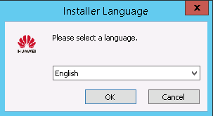

Click **OK**.

The **Welcome to Huawei eSight For SCOM plugin 1.1.200 Setup** window is displayed, as shown in Figure 2-2.

Welcome to Huawei eSight For SCOM plugin 1.1.200 Setup

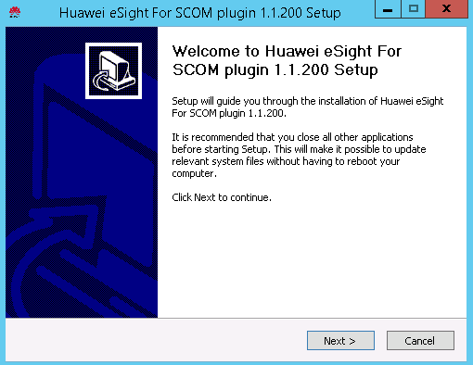

Click **Next**.

The **Choose Install Location** window is displayed, as shown in Figure 2-3.

Choose Install Location

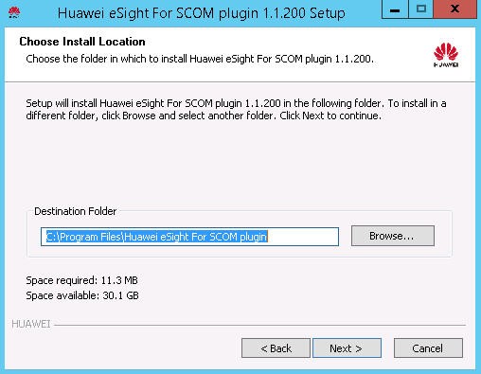

Retain the default installation path or click **Browse** to change the installation path, and click **Next**.

The **Select features to install** window is displayed, as shown in Figure 2-4.

Select features to install

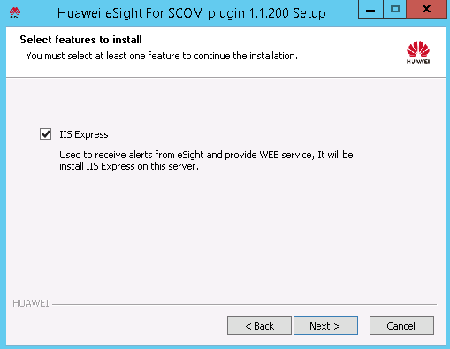

Select required functions and click **Next**.

The **IP/Port Configuration** window is displayed, as shown in Figure 2-5.

IP/Port Configuration

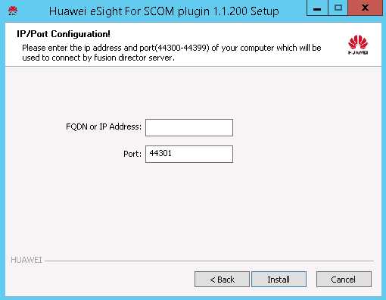

Enter the IP address and port number of the SCOM server that is used to connect to eSight. (The port number ranges from 44300 to 44399. You are advised to retain the default value **44301**.) Click **Install**.

The Huawei SCOM plug-in installation starts, as shown in Figure 2-6.

Installing the Huawei SCOM plug-in

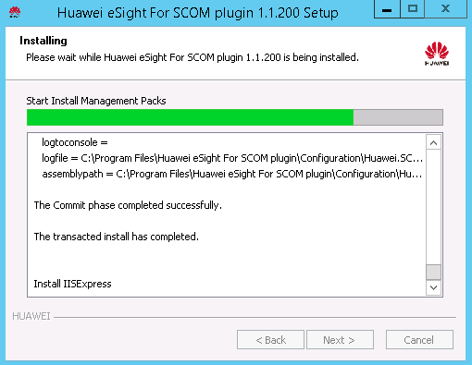

After the installation is complete, the **Completing Huawei eSight For SCOM plugin 1.1.200 Setup** window is displayed, as shown in Figure 2-7.

Completing Huawei eSight For SCOM plugin 1.1.200 Setup

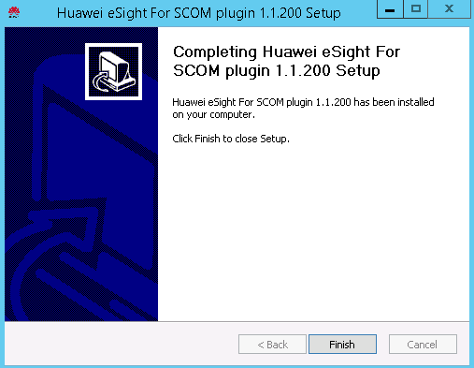

Click **Finish**.

The Huawei SCOM plug-in installation is complete.

Choose **Start** > > **Operations Console**.



The SCOM main window is displayed, as shown in Figure 2-8.

SCOM main window

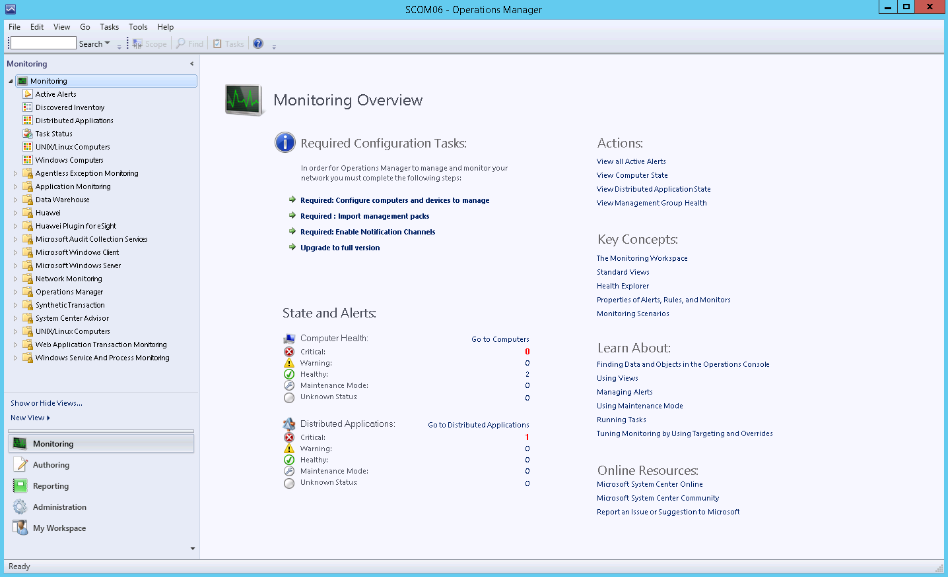

Choose **Administration** > **Management Packs**.

The **Management Packs** window is displayed, as shown in Figure 2-9.

Management Packs

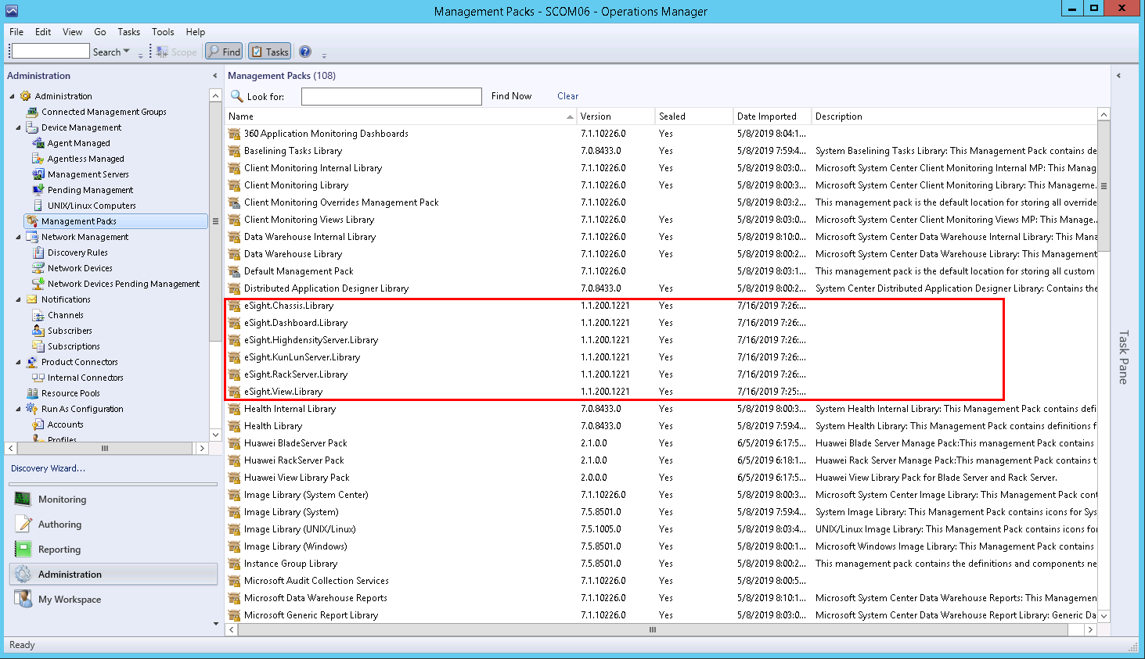

After the Huawei SCOM plug-in is successfully installed, the Manage Package (MP) packages in the red box are displayed in the **Management Packs** window.

After the MP packages are successfully installed, the nodes in the red box are displayed in the SCOM main window, as shown in Figure 2-10.

SCOM main window

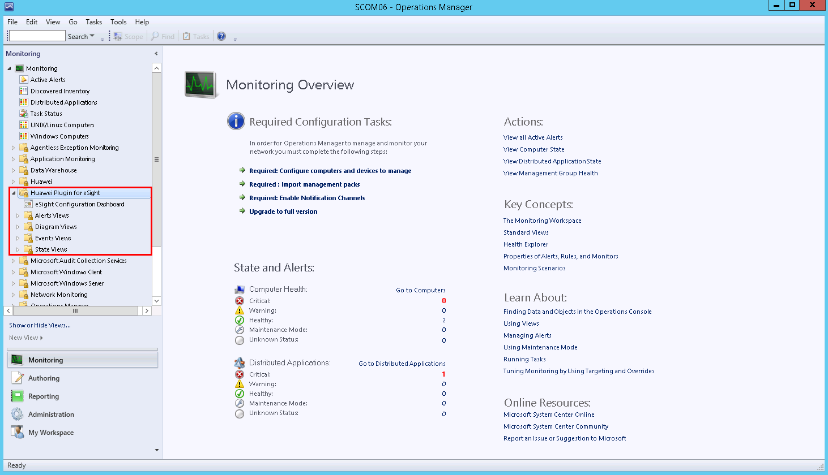

----End

## Uninstalling the Huawei SCOM Plug-in

You need to close the SCOM window before uninstalling the Huawei SCOM plug-in.

Uninstalling the Huawei SCOM Plug-in from the Control Panel

Choose **Start > Control Panel > Programs > Programs and Features**.

The **Uninstall or change a program** window is displayed, as shown in Figure 2-11.

Uninstall or change a program

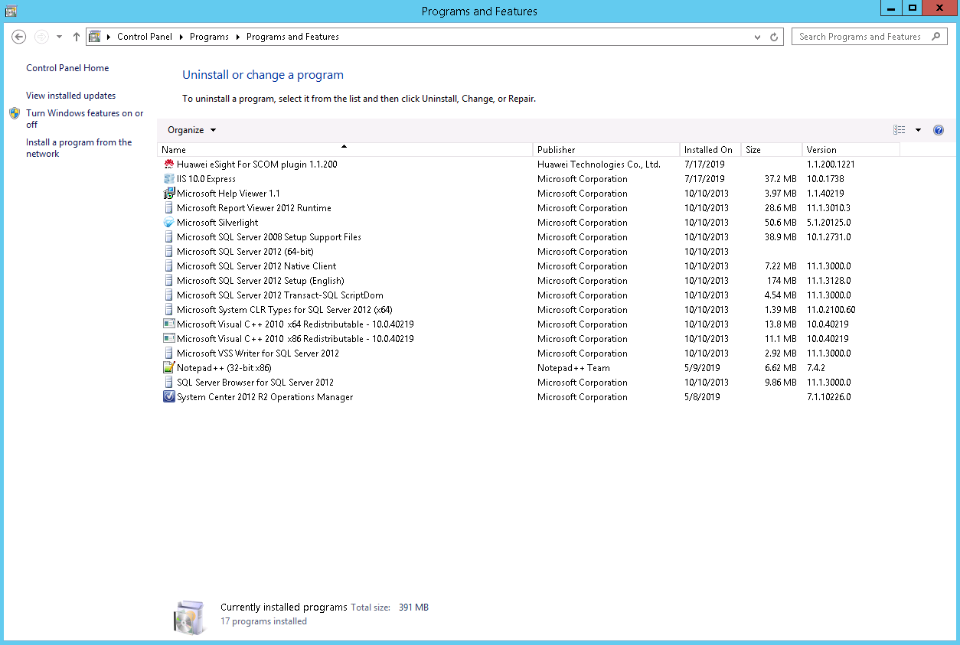

Double-click the Huawei SCOM plug-in (for example, **Huawei eSight For SCOM Plugin 1.1.200**).

A confirmation dialog box is displayed, as shown in Figure 2-12.

Dialog box

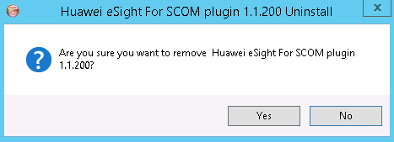

Click **Yes**.

The dialog box asking you whether to uninstall IIS Express is displayed, as shown in Figure 2-13.

Dialog box

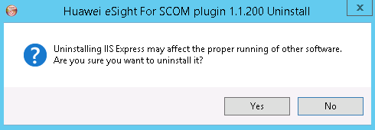

IIS Express is responsible for the communication between the plug-in and SCOM. After IIS Express is uninstalled, it will be reinstalled when the Huawei SCOM plug-in is installed.

* If IIS Express needs to be uninstalled, click **Yes**.
* If IIS Express does not need to be uninstalled, click **No**.

Click **Yes** or **No**.

The Huawei SCOM plug-in uninstallation starts, as shown in Figure 2-14.

Uninstalling the Huawei SCOM plug-in

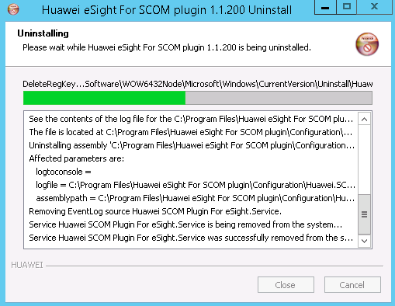

After the uninstallation is complete, the dialog box shown in Figure 2-15 is displayed.

Uninstallation completed

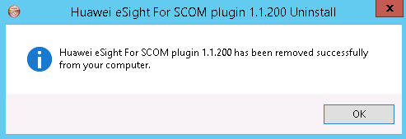

Click **OK**.

The Huawei SCOM plug-in is uninstalled.

----End

Uninstalling the Huawei SCOM Plug-in from the Installation Directory

Go to the installation directory of the Huawei SCOM plug-in (**C:\Program Files\Huawei eSight For SCOM plugin**), as shown in Figure 2-16.

Installation directory of the Huawei SCOM plug-in

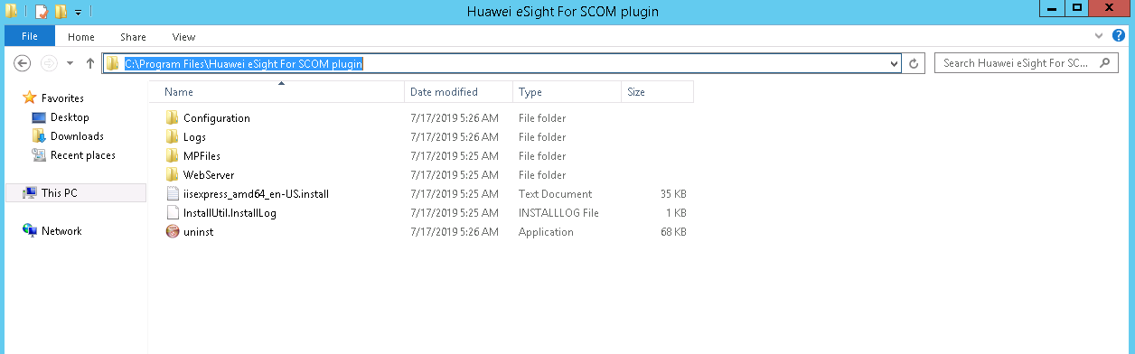

Double-click **uninst**.

A confirmation dialog box is displayed, as shown in Figure 2-17.

Dialog box



Click **Yes**.

The dialog box asking you whether to uninstall IIS Express is displayed, as shown in Figure 2-18.

Dialog box



IIS Express is responsible for the communication between the plug-in and SCOM. After IIS Express is uninstalled, it will be reinstalled when the Huawei SCOM plug-in is installed.

* If IIS Express needs to be uninstalled, click **Yes**.
* If IIS Express does not need to be uninstalled, click **No**.

Click **Yes** or **No**.

The Huawei SCOM plug-in uninstallation starts, as shown in Figure 2-19.

Uninstalling the Huawei SCOM plug-in



After the uninstallation is complete, the dialog box shown in Figure 2-20 is displayed.

Uninstallation completed



Click **OK**.

The Huawei SCOM plug-in is uninstalled.

----End

# Configuring eSight

3.1 Adding eSight

3.2 Editing eSight

3.3 Deleting eSight

## Adding eSight



* KunLun servers have many components. When you add a KunLun server on eSight and set the discovery time to the maximum value 60 seconds, you can click the refresh button to increase the speed of obtaining component information, as shown in Figure 3-1. For details, see the [*eSight V300R010C00SPC200, 300, and 500 Product Documentation*](https://support.huawei.com/hedex/hdx.do?docid=EDOC1100044382&lang=en&idPath=8221819%7C8221821%7C8221823%7C9184477).
* A maximum of 50 eSight instances can be added.

Accelerating the obtaining of KunLun server component information

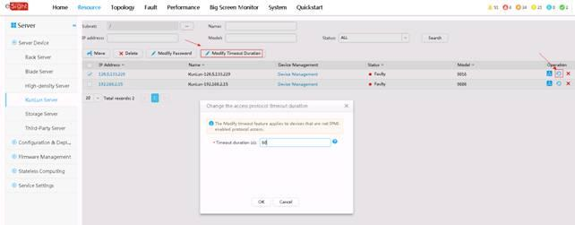

Set a whitelist and obtain the third-party system ID of eSight.

By default, a whitelist of eSight northbound ports is configured. To add an eSight system properly, you must add the IP address of the server where SCOM is located to the whitelist of eSight northbound ports.

1. Log in to the eSight WebUI.
2. Choose **System** > **Northbound Integration** > **Third-party System** > **Create**.

The **Third-party System** page is displayed, as shown in Figure 3-2.

Third-party System

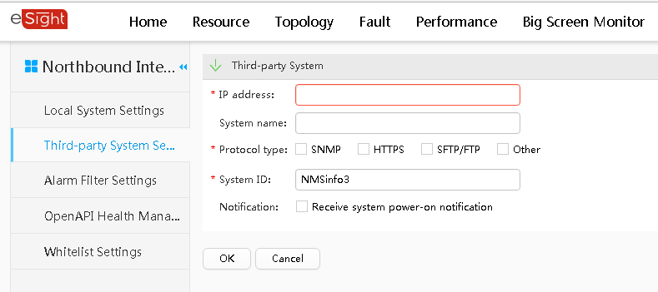

The default value of **System ID** of eSight is **NMSinfo**+*Number of third-party systems*.

1. Set the following parameters:

* **IP address**: Set this parameter to the IP address of the SCOM server.
* **Protocol type**: Select **HTTPS**.
* **System ID**: Retain the default value or enter a new value. The value can be an IP address or a string of 1 to 64 characters, including digits (0-9), lowercase letters (a-z), uppercase letters (A-Z), and special characters @_- (), .^$~`!.

1. Click **OK**.

The IP address of the SCOM server is set as a whitelist, as shown in Figure 3-3.

Set successfully

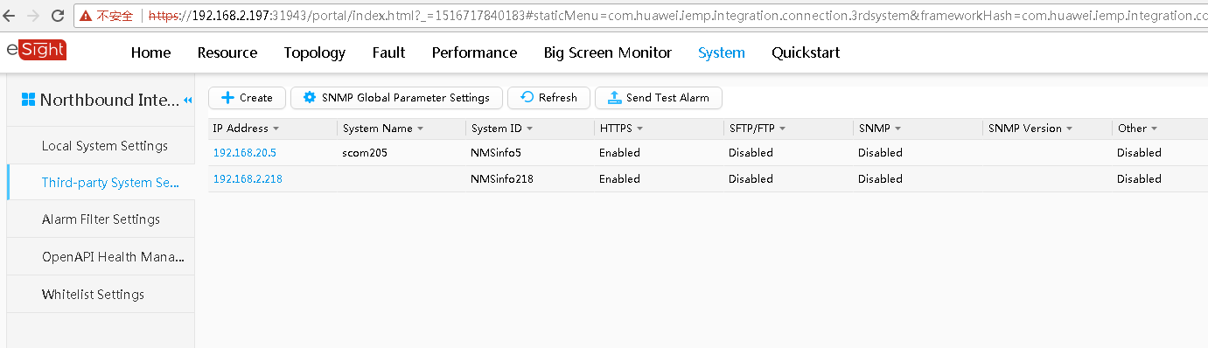

In the third-party system list area on the right, the value of **System ID** in the row where the SCOM server IP address is located is the eSight third-party system ID.

Choose **Start** > > **Operations Console**.



The SCOM main window is displayed, as shown in Figure 3-4.

SCOM main window



Choose **Monitoring** > **Huawei Plugin for eSight** > **eSight Configuration Dashboard**.

The **eSight Configuration Dashboard** window is displayed, as shown in Figure 3-5.

eSight Configuration Dashboard

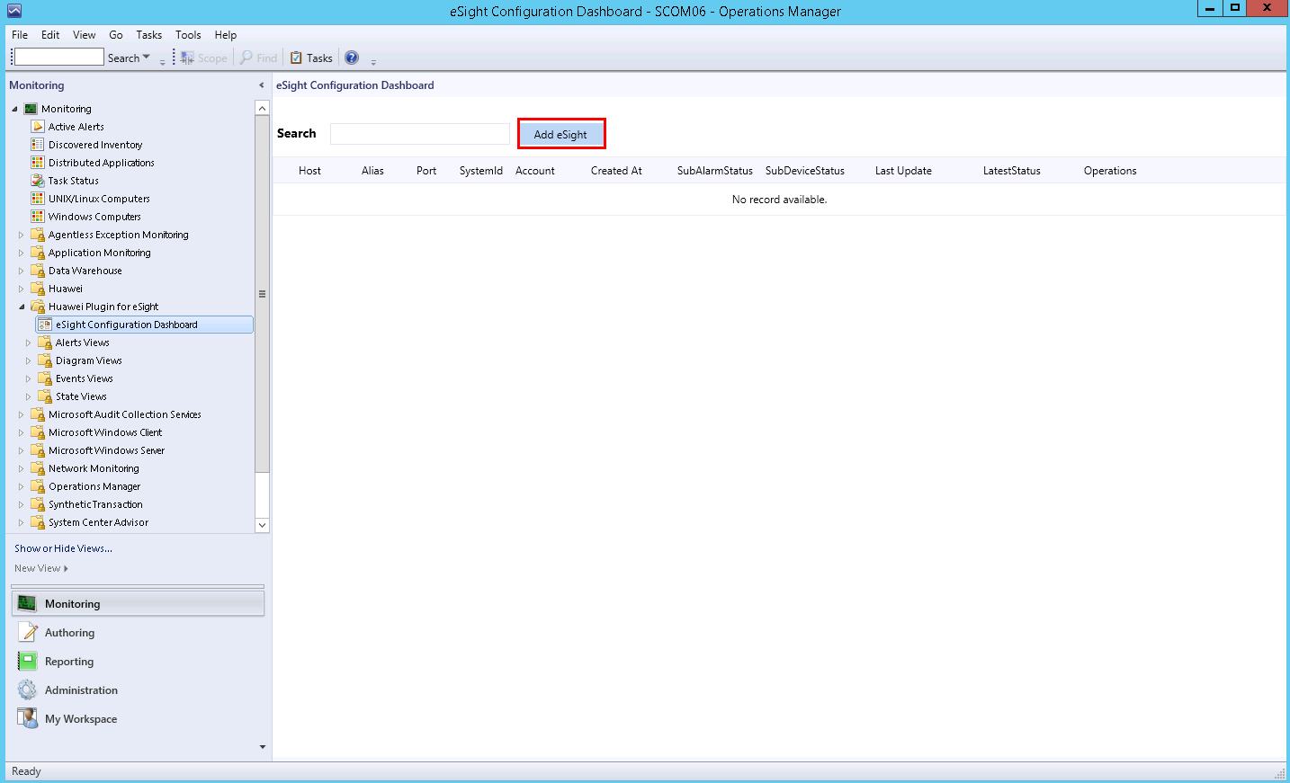

Click **Add eSight**.

The **Add eSight** page is displayed, as shown in Figure 3-6.

Add eSight

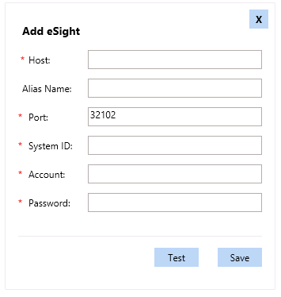

Table 3-1 describes the parameters.

Parameter description

| Parameter | Parameter Description | Value | Mandatory |
| --- | --- | --- | --- |
| Host | eSight IP address | The value is in the XXX.XXX.XXX.XXX format. X is an integer. | Yes |
| Alias Name | Customized eSight name | The value is a string of 1 to 100 characters, including letters, digits, underscores (_), hyphens (-), and periods (.). | No |
| Port | eSight northbound port number | The default value is **32102**. | Yes |
| SystemID | Third-party system ID | Value obtained in Step 1.3. | Yes |
| Account | eSight northbound port user name | The default value is **openApiUser**. | Yes |
| Password | eSight northbound port password | The default value is **Changeme_123**. | Yes |

Enter eSight information, and click **Test** to test whether the SCOM server can connect to eSight.

If the test is successful, "eSight authentication passes" is displayed, as shown in Figure 3-7. If the test fails, the failure cause is displayed. Modify eSight information as prompted.

Successful test

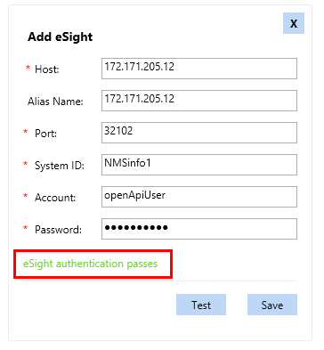

Click **Save**.

The eSight is added successfully, as shown in Figure 3-8.

eSight added successfully

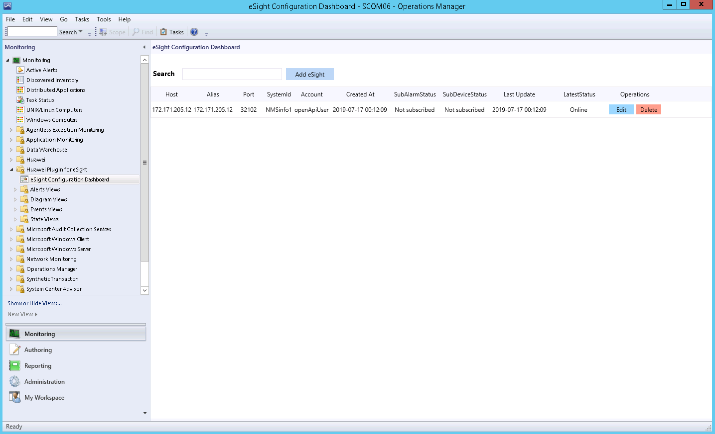

----End

## Editing eSight

Choose **Start** > > **Operations Console**.



The SCOM main window is displayed, as shown in Figure 3-9.

SCOM main window



Choose **Monitoring** > **Huawei Plugin for eSight** > **eSight Configuration Dashboard**.

The **eSight Configuration Dashboard** window is displayed, as shown in Figure 3-10.

eSight Configuration Dashboard

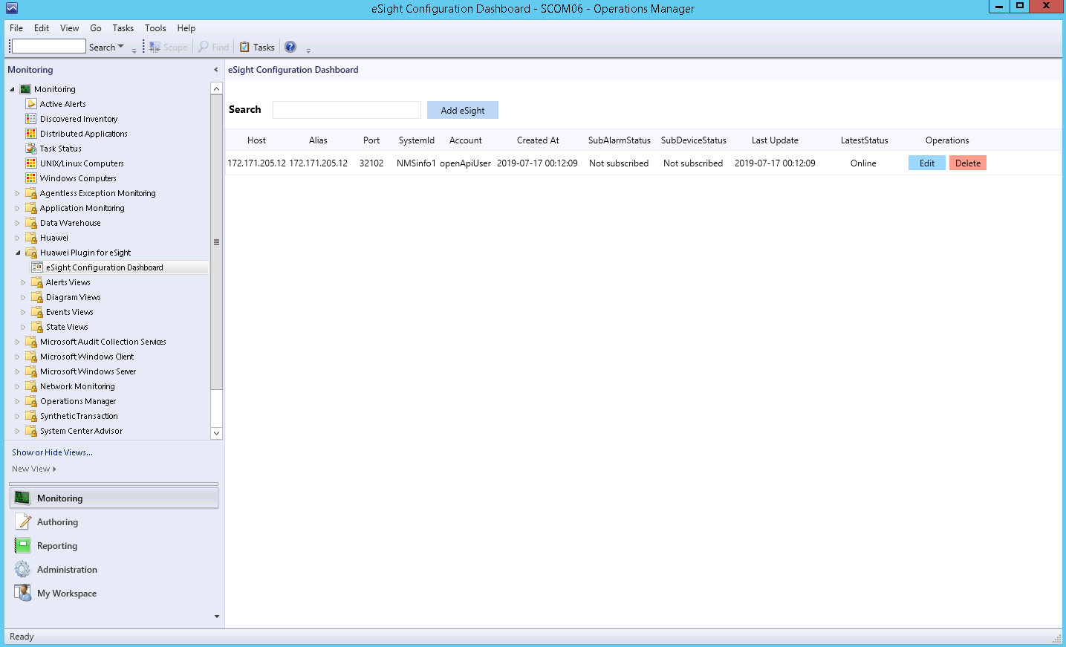

If the eSight information in the right pane is empty, no eSight has been connected.

Click **Edit** in the row where eSight is located in the right pane. **Edit** is in the **Operations** column.

The **Edit eSight** window is displayed, as shown in Figure 3-11.

Edit eSight

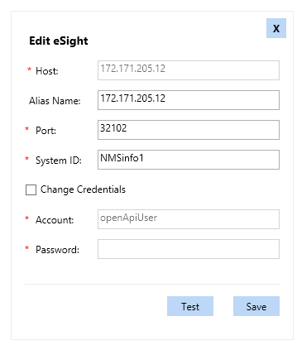

Edit eSight information according to Table 3-1.



* The eSight IP address cannot be modified.
* **Change Credentials** must be selected if the eSight northbound port user name and password are to be changed.

Click **Save**.

The eSight is successfully edited, as shown in Figure 3-12. On this page, you can check whether the modified information is consistent with the target.

Modified eSight information

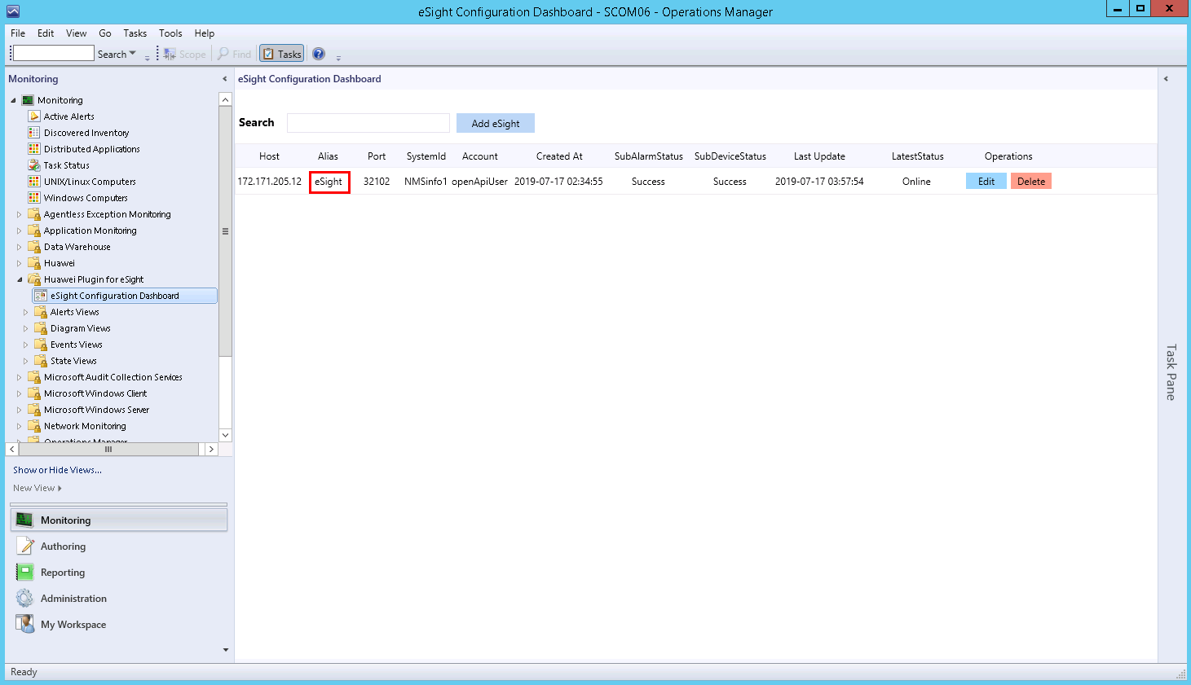

----End

## Deleting eSight

Choose **Start** > > **Operations Console**.



The SCOM main window is displayed, as shown in Figure 3-13.

SCOM main window



Choose **Monitoring** > **Huawei Plugin for eSight** > **eSight Configuration Dashboard**.

The **eSight Configuration Dashboard** window is displayed, as shown in Figure 3-14.

eSight Configuration Dashboard



If the eSight information in the right pane is empty, no eSight has been connected.

Click **Delete** in the row where eSight is located in the right pane. **Delete** is in the **Operations** column.

A confirmation dialog box is displayed, as shown in Figure 3-15.

Dialog box

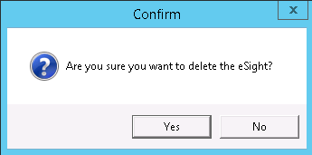

Click **Yes**.

The eSight is successfully deleted, as shown in Figure 3-16. On this page, you can check whether the target eSight has been deleted.

eSight deleted successfully

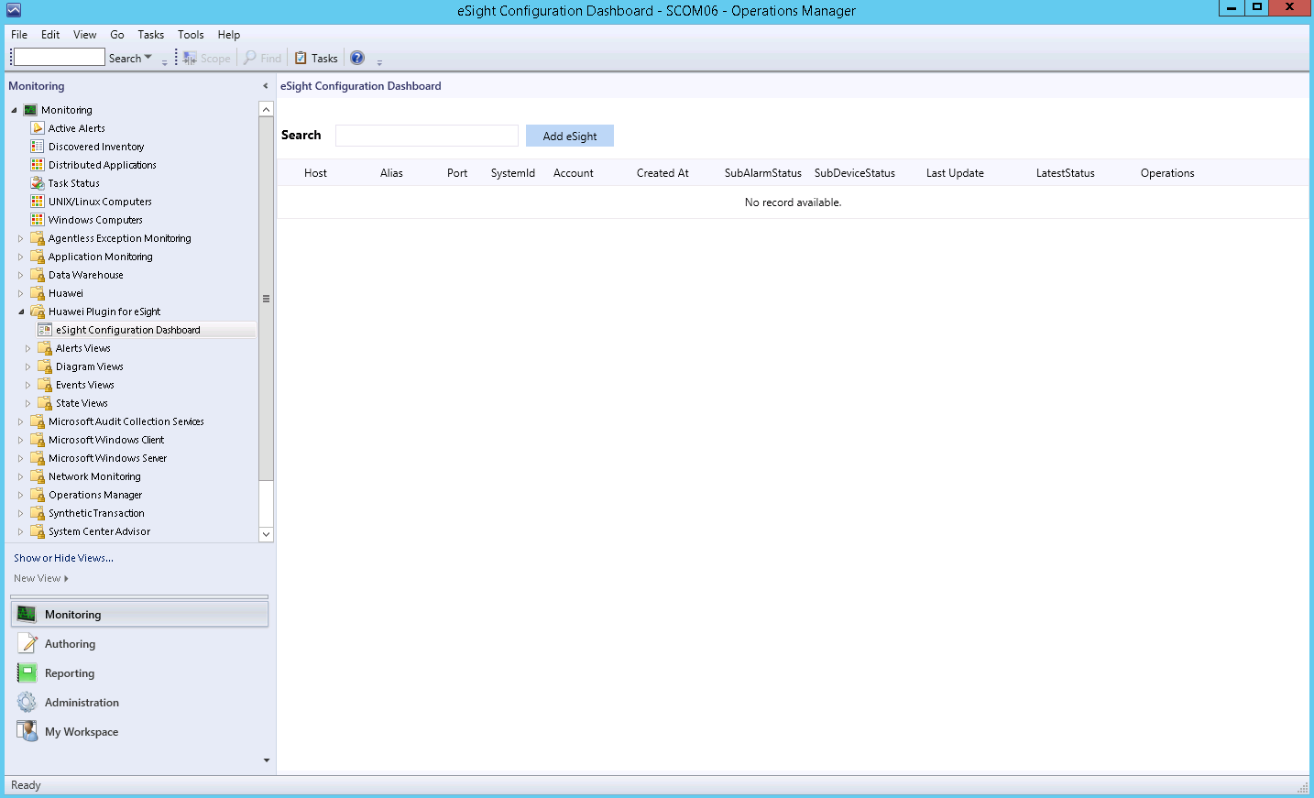

----End

# Viewing the Basic Information and Status of Servers

4.1 Viewing the Basic Information and Status of a Blade Server

4.2 Viewing the Basic Information and Status of a Rack Server

4.3 Viewing the Basic Information and Status of a High-Density Server

4.4 Viewing the Basic Information and Status of a KunLun Server

## Viewing the Basic Information and Status of a Blade Server

Choose **Start** > > **Operations Console**.



The SCOM main window is displayed, as shown in Figure 4-1.

SCOM main window



Choose **Monitoring** > **Huawei Plugin for eSight** > **State Views** > **Chassis State**.

The **Chassis State** window is displayed, as shown in Figure 4-2. On this page, the managed chassis are displayed in different rows, and the status of the monitored components on each chassis is displayed in different columns.

Chassis State

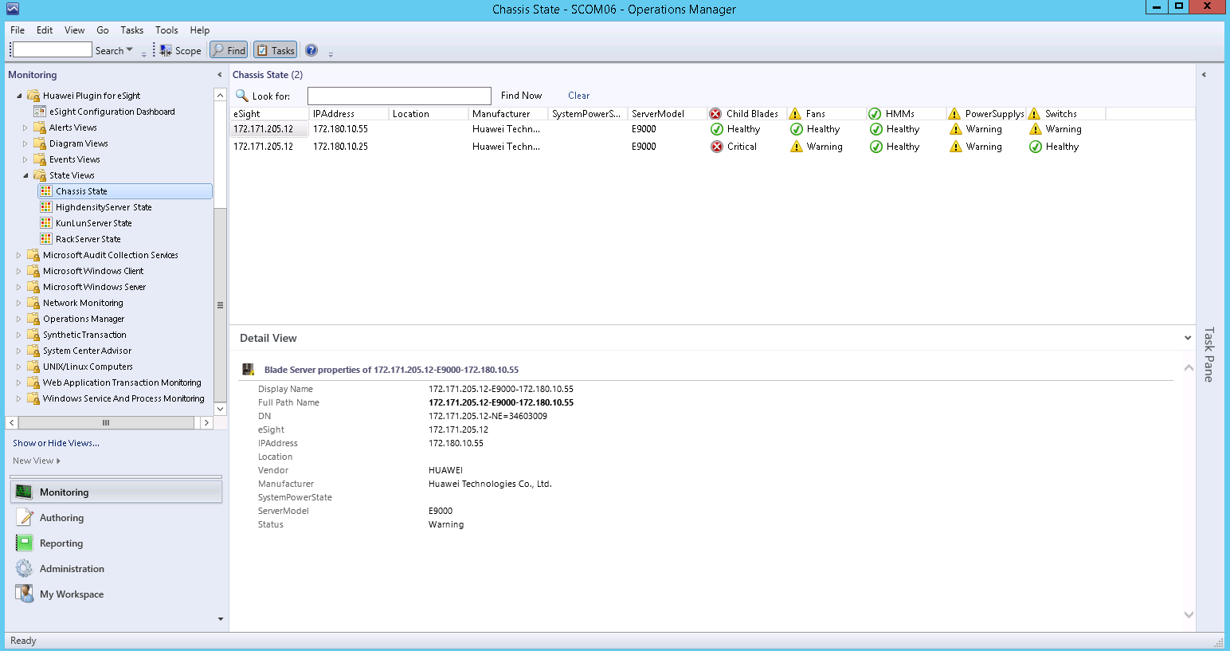

In the **Chassis State** area, you can click any position in the row of a chassis to view details about the chassis in the **Detail View** area.



The component health status is described as follows:

* : Healthy, absent, or unknown status



* *:* Minor alarms



* *:* Major or critical alarms



The overall health status depends on the server system status and is irrelevant to the component status.

Set the components and monitoring parameters to be displayed.

1. Right-click the name or status of a component and choose **Personalize View...** from the shortcut menu.

The **Personalize View** window is displayed, as shown in Figure 4-3.

Personalize View

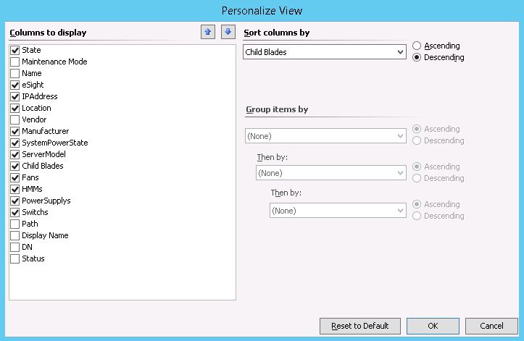

1. Select the components to be monitored, and click **OK**.

The components to be monitored are modified successfully.

1. Right-click the component status (for example, **Healthy** under **Fans**) and choose **Open** > **State View** from the shortcut menu or double-click the component status.

The **State** window of the component is displayed, as shown in Figure 4-4.

State

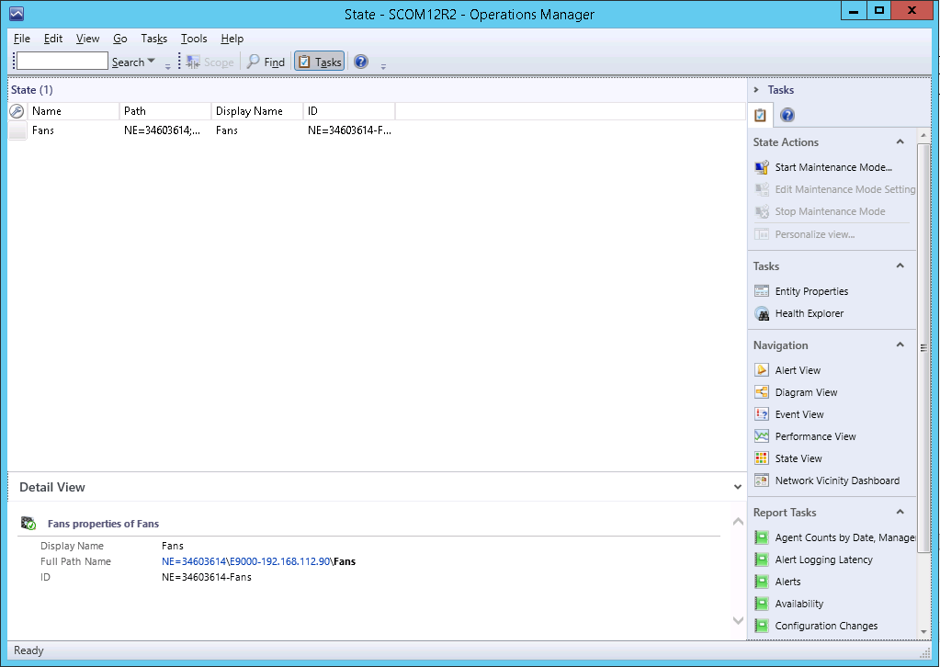

1. Right-click a row in the **State** area and choose **Personalize View...** from the shortcut menu.

The **Personalize View** window is displayed, as shown in Figure 4-5.

Personalize View

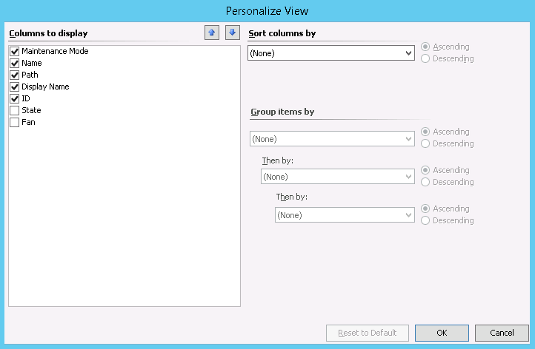

1. In the **Columns to display** list box, select the parameters to be displayed, and click **OK**.

The **State** window is displayed, as shown in Figure 4-6.

State

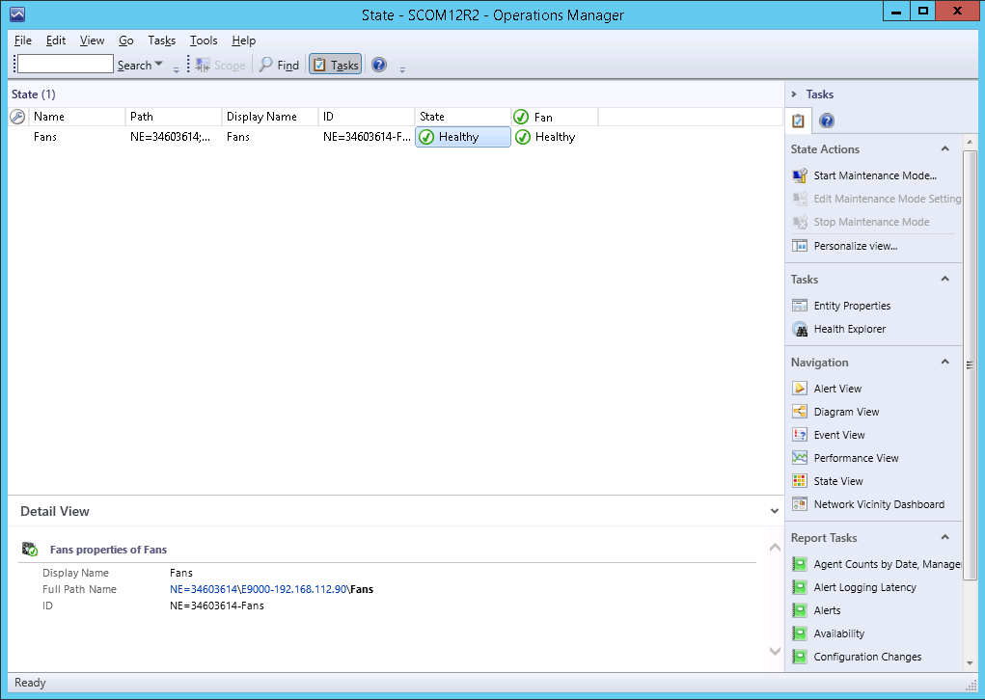

Table 4-1 lists the blade server components and parameters that can be monitored by the Huawei SCOM plug-in.

Blade server components and parameters that can be monitored

| Service Name | Component | Parameter |
| --- | --- | --- |
| Fan | Fan | * UUID: UUID * State: health status * PresentState: presence status * ControlModel: control type * RotatePercent: rotation percentage * fanSpeed: fan speed * fanInfo: fan information * fanVersion: fan version |
| PowerSupply | PSU | * UUID: UUID * State: health status * PresentState: presence status * PowerMode: PSU working mode * RatingPower: rated power * RuntimePower: real-time power |
| Switch | Switch module | * UUID: UUID * State: health status * BladeVersion: blade version * SwitchType: switch module model * ProductName: product name * BoardManufacturer: mainboard manufacturer * BoardPartNumber: mainboard part number * BoardSerialNumber: mainboard serial number * BoardManufactureDate: mainboard manufacturing date * ProductDescription: product description * ProductManufacturer: product manufacturer * ProductPartNumber: product part number * ProductSerialNumber: product serial number |
| Child Blade | Blade | * UUID: UUID * State: health status * PresentState: presence status * BmcIP: BMC IP address * BmcMask: BMC mark * ProductName: product name * BladeVersion: blade version * BoardSerialNumber: mainboard serial number * BoardManufactureDate: mainboard manufacturing date * ProductDescription: product description * ProductSerialNumber: product serial number * SystemCPUUsage: system CPU usage |
| HMM | E9000 management module | * UUID: UUID * State: health status * PresentState: presence status * ProductName: product name * AmbientTemp: ambient temperature * InletTemp: air inlet temperature * LSWTemp: switch module temperature * OutletTemp: air outlet temperature * SoftwareVersion: software version * BoardSerialNumber: mainboard serial number * ProductSerialNumber: product serial number * smmOtherVersion: other firmware versions * smmHostname: host name * smmRedundancy: presence status of the active and standby management modules |
| CPU | Blade server CPU | * State: health status * UUID: UUID * PresentState: CPU presence status * CPUInfo: CPU information |
| Disk | Blade server hard disk | * State: health status * UUID: UUID * PresentState: hard disk presence status * DiskLocation: hard disk location * DiskSerialNumber: hard disk serial number * DiskINterfaceType: hard disk interface type * DiskCapcity: hard disk capacity * DiskManufacturer: hard disk manufacturer |
| Memory | Blade server memory | * State: health status * UUID: UUID * PresentState: memory presence status * Manufacturer: manufacturer * Frequency: memory frequency * Capacity: memory capacity |
| Mezz | Blade server mezzanine card | * State: health status * UUID: UUID * PresentState: mezzanine card presence status * MezzInfo: mezzanine card information * MezzLocation: mezzanine card location * MezzMac: mezzanine card MAC address |
| RaidController | Blade server RAID controller card | * State: health status * UUID: UUID * Type: RAID controller card type * DeviceInterface: RAID controller card hardware interface * FwVersion: RAID controller card firmware version * BBUPresence: BBU presence status * BBUType: BBU type |

----End

## Viewing the Basic Information and Status of a Rack Server

Choose **Start** > > **Operations Console**.



The SCOM main window is displayed, as shown in Figure 4-7.

SCOM main window



Choose **Monitoring** > **Huawei Plugin for eSight** > **State Views** > **RackServer State**.

The **RackServer State** window is displayed, as shown in Figure 4-8. This window displays the health status and basic information of managed servers.

RackServer State

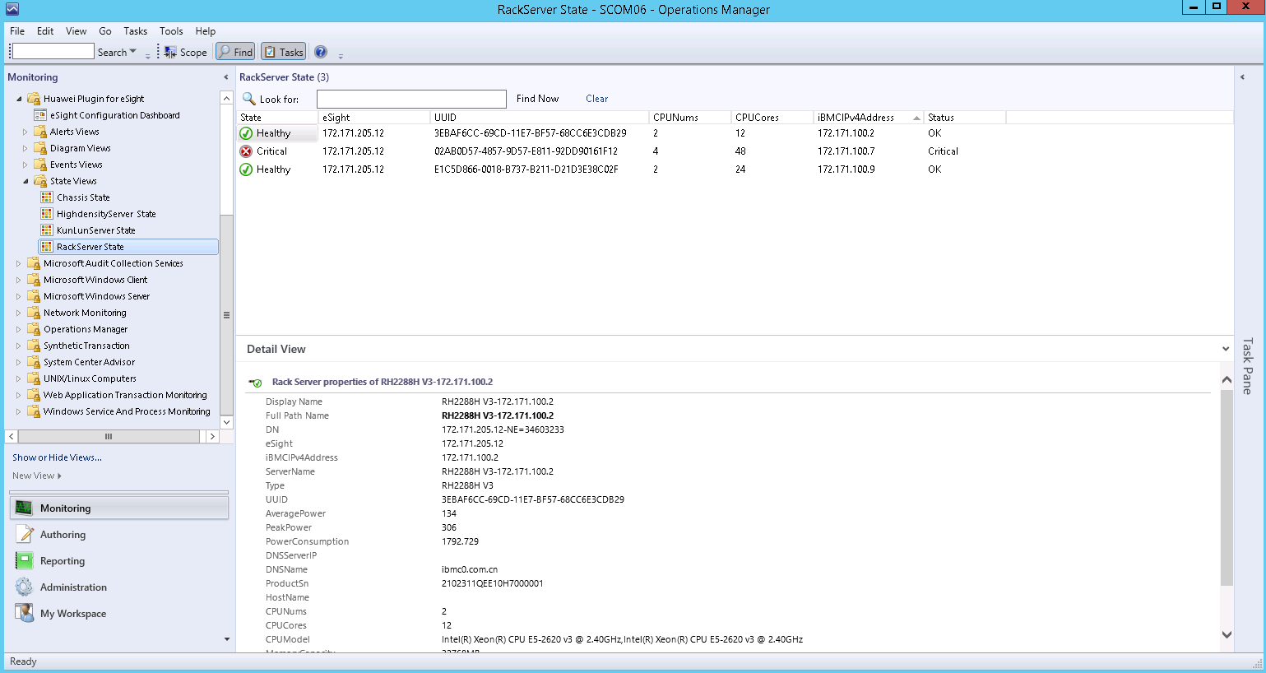

In the **RackServer State** area, you can click any position in the row of a server to view details about the server in the **Detail View** area.



The component health status is described as follows:

* *:* Healthy, absent, or unknown status



* *:* Minor alarms



* *:* Major or critical alarms



The overall health status depends on the server system status and is irrelevant to the component status.

Set the monitoring parameters to be displayed. For details, see Step 3 in 4.1 Viewing the Basic Information and Status of a Blade Server.

Table 4-2 lists the rack server parameters that can be monitored by the Huawei SCOM plug-in.

Rack server parameters that can be monitored

| Parameter | Description | Example Value |
| --- | --- | --- |
| iBMCIPv4Address | BMC IP address | 10.10.10.7 |
| ServerName | Server name | 2488H V5-10.10.10.7 |
| Type | Server model | 2488H V5 |
| UUID | UUID | E1C5D866-0018-AC11-B211-D21D60243331 |
| Status | Health status | OK |
| AveragePower | Average power | 282 |
| PeakPower | Peak power | 626 |
| PowerConsumption | Power consumption | 1156 |
| DNSServerIP | DNS IP address | 10.10.10.8 |
| DNSName | DNS name | com |
| ProductSn | Product SN | 42353423 |
| HostName | Host name | qwrqw |
| CPUNums | Number of CPUs | 4 |
| CPUCores | Number of CPU cores | 48 |
| CPUModel | CPU model | Intel(R) Xeon(R) Gold 5118 CPU @ 2.30GHz |
| MemoryCapacity | Memory capacity | 131072MB |
| BMCVersion | BMC version | 3.17 |
| AssertTag | Asset label | test |

----End

## Viewing the Basic Information and Status of a High-Density Server

Choose **Start** > > **Operations Console**.



The SCOM main window is displayed, as shown in Figure 4-9.

SCOM main window



Choose **Monitoring** > **Huawei Plugin for eSight** > **State Views** > **HighdensityServer State**.

The **HighdensityServer State** window is displayed, as shown in Figure 4-10. On this page, the managed servers are displayed in different rows, and the status of the monitored components on each server is displayed in different columns.

HighdensityServer State

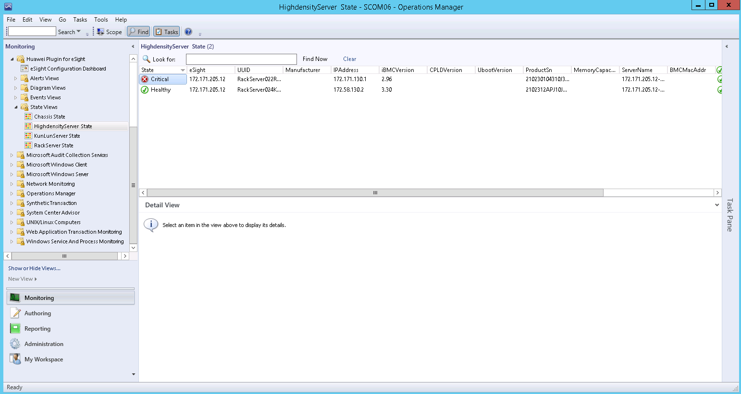

In the **HighdensityServer State** area, you can click any position in the row of a server to view details about the server in the **Detail View** area.



The component health status is described as follows:

* *:* Healthy, absent, or unknown status



* *:* Minor alarms



* *:* Major or critical alarms



The overall health status depends on the server system status and is irrelevant to the component status.

Set the components and monitoring parameters to be displayed. For details, see step Step 3 in 4.1 Viewing the Basic Information and Status of a Blade Server.

Table 4-3 lists the high-density server components and parameters that can be monitored by the Huawei SCOM plug-in.

High-density server components and parameters that can be monitored

| Service Name | Component | Parameter |
| --- | --- | --- |
| Fan | Fan | * UUID: UUID * State: health status * PresentState: presence status * RotatePercent: rotation percentage * Speed(RPM): fan speed |
| PowerSupply | PSU | * UUID: UUID * State: health status * PresentState: presence status * Manufacturer: manufacturer * InputMode: input mode * Model: type * PowerRating: rated power * InputPower: input power |
| Child Board | Server node | * UUID: UUID * State: health status * IpAddress: IP address * ProductSn: product SN * Type: type |
| CPU | Server node CPU | * State: health status * UUID: UUID * PresentState: CPU presence status * Manufacturer: manufacturer * Type: type * Frequency: frequency (MHz) * CoreCount: number of cores |
| Disk | Server node hard disk | * State: health status * UUID: UUID * PresentState: hard disk presence status * Locator: hard disk location * Diskcapacity(GB): hard disk capacity * IndterfaceType: hard disk interface type |
| Memory | Server node memory | * State: health status * UUID: UUID * PresentState: memory presence status * Manufacturer: manufacturer * Frequency: memory frequency * Size: memory capacity |
| RaidController | Server node RAID controller card | * State: health status * UUID: UUID * Type: RAID controller card type * DeviceInterface: RAID controller card hardware interface * FirmwareVersion: RAID controller card firmware version * DirverVersion: RAID controller card driver version * BBUType: BBU type |

----End

## Viewing the Basic Information and Status of a KunLun Server

Choose **Start** > > **Operations Console**.



The SCOM main window is displayed, as shown in Figure 4-11.

SCOM main window



Choose **Monitoring** > **Huawei Plugin for eSight** > **State Views** > **KunlunServer State**.

The **KunlunServer State** window is displayed, as shown in Figure 4-12. On this page, the managed servers are displayed in different rows, and the status of the monitored components on each server is displayed in different columns.

KunlunServer State

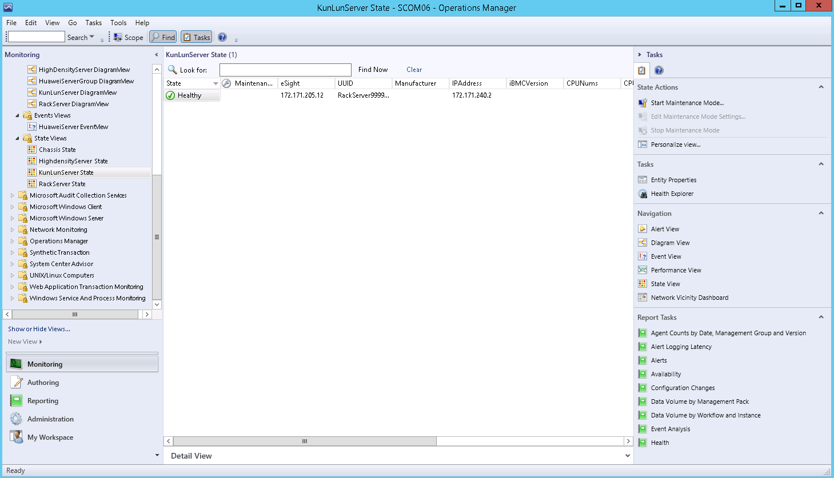

In the **KunlunServer State** area, you can click any position in the row of a server to view details about the server in the **Detail View** area.



The component health status is described as follows:

* *:* Healthy, absent, or unknown status



* *:* Minor alarms



* *:* Major or critical alarms



The overall health status depends on the server system status and is irrelevant to the component status.

Set the components and monitoring parameters to be displayed. For details, see step Step 3 in 4.1 Viewing the Basic Information and Status of a Blade Server.

Table 4-4 lists the KunLun server components and parameters that can be monitored by the Huawei SCOM plug-in.

KunLun server components and parameters that can be monitored

| Service Name | Component | Parameter |
| --- | --- | --- |
| Fan | Fan | * UUID: UUID * State: health status * PresentState: presence status * RotatePercent: rotation percentage * Speed(RPM): fan speed |
| PowerSupply | PSU | * UUID: UUID * State: health status * PresentState: presence status * Manufacturer: manufacturer * InputMode: input mode * Model: type * PowerRating: rated power * InputPower: input power |
| PhysicalDisk | Hard disk | * State: health status * UUID: UUID * PresentState: hard disk presence status * Locator: hard disk location * Diskcapacity(GB): hard disk capacity * IndterfaceType: hard disk interface type |
| RaidController | RAID controller card | * State: health status * UUID: UUID * Type: RAID controller card type * DeviceInterface: RAID controller card hardware interface * FirmwareVersion: RAID controller card firmware version * DirverVersion: RAID controller card driver version * BBUType: BBU type |

----End

# Viewing an Event List

Choose **Start** > > **Operations Console**.



The SCOM main window is displayed, as shown in Figure 5-1.

SCOM main window



Choose **Monitoring** > **Huawei Plugin for eSight** > **Events Views** > **HuaweiServer EventView**.

In the **HuaweiServer EventView** window that is displayed, click an event to view its details, as shown in Figure 5-2.

HuaweiServer EventView

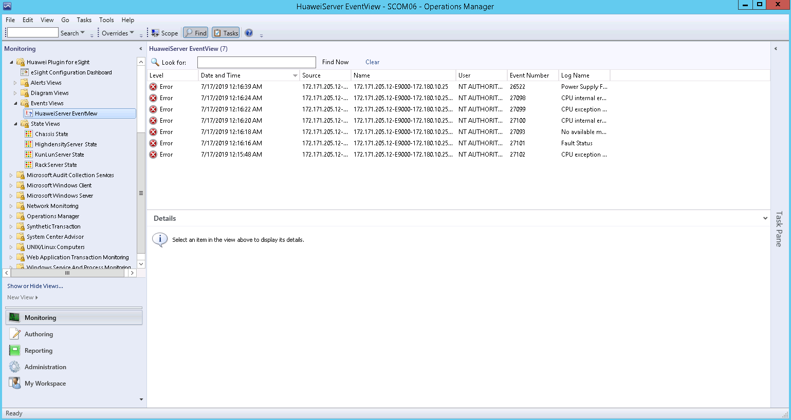

Table 5-1 describes the parameters.

Parameter description

| Parameter | Description |
| --- | --- |
| Level | Event type. The options are as follows:   * Information: system running event * Warning: minor alarm * Error: major or critical alarm |
| Date and Time | Date and time when an event is generated |
| Source | Sensor that generates an event |
| Name | Device where an event is generated |
| User | Current user |
| Event Number | Event number. The value ranges from 0 to 65535. |
| Log Name | Event name |
| Logging Computer | Current login device |
| Rule Name | Rule name |

----End

# Viewing an Alarm List

Choose **Start** > > **Operations Console**.



The SCOM main window is displayed, as shown in Figure 6-1.

SCOM main window



Choose **Monitoring** > **Huawei Plugin for eSight** > **Alerts Views** > **HuaweiServer AlertView**.

In the **HuaweiServer AlertView** window that is displayed, click an alarm to view its details, as shown in Figure 6-2.

HuaweiServer AlertView

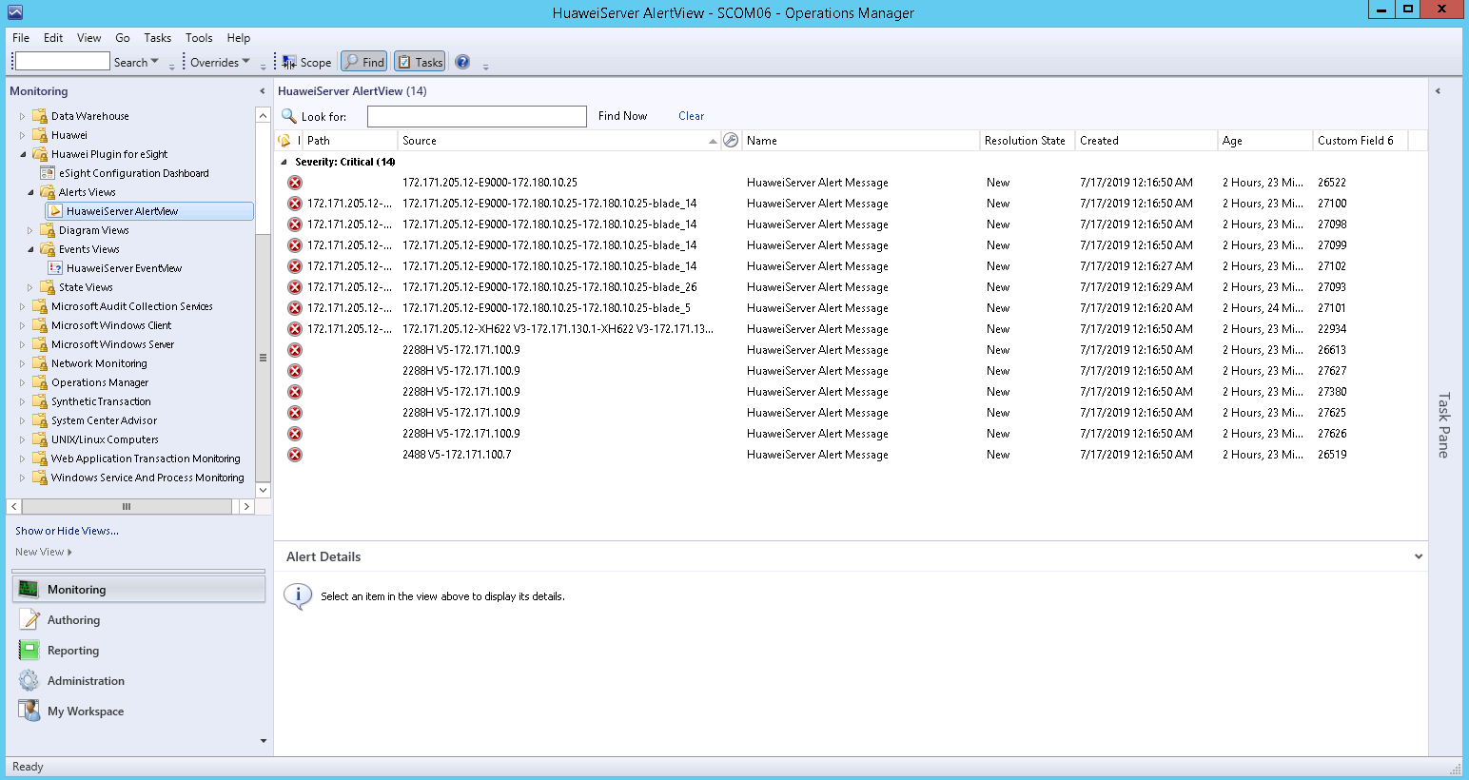

Table 6-1 describes the parameters.

Parameter description

| Parameter | Description |
| --- | --- |
| lcon | Alarm type. The options are as follows:   * Warning: minor alarm * Error: major or critical alarm |
| Path | Sensor that generates an alarm |
| Source | Device where an alarm is generated |
| Name | Alarm name |
| Resolution State | Handling status |
| Created | Time when an alarm is generated |
| Age | Duration of an alarm |

----End

# Viewing Server Topologies

7.1 Viewing a Huawei Server Topology

7.2 Viewing a Blade Server Topology

7.3 Viewing a Rack Server Topology

7.4 Viewing a High-Density Server Topology

7.5 Viewing a KunLun Server Topology

## Viewing a Huawei Server Topology

Huawei server topologies include the topologies of blade servers, rack servers, high-density servers, and KunLun servers. The following sections describe different types of server topologies.

Choose **Start** > > **Operations Console**.



The SCOM main window is displayed, as shown in Figure 7-1.

SCOM main window



Choose **Monitoring** > **Huawei Plugin for eSight** > **Diagram Views** > **HuaweiServerGroup DiagramView**.

The **HuaweiServerGroup DiagramView** window is displayed, as shown in Figure 7-2.

HuaweiServerGroup DiagramView

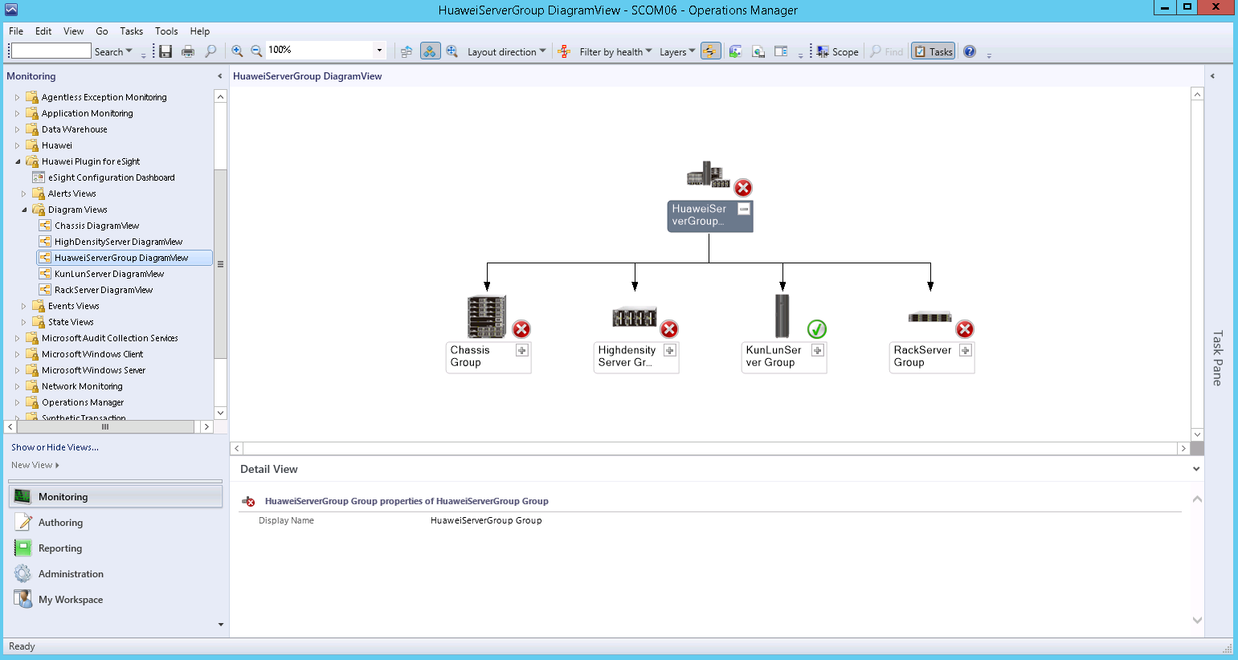

If the topology is not refreshed in time, you can perform the following steps to refresh it:

Open the CLI of the SCOM server.

Access the SCOM installation path (**C:\Program Files\System Center Operations Manager 2012\Console**) on the CLI.

Run the following command to refresh the SCOM window:

**Microsoft.EnterpriseManagement.Monitoring.Console.exe" /clearcache**

In the **HuaweiServerGroup DiagramView** area, click on any server icon to expand the topology of the server type, as shown in Figure 7-3.



Topology

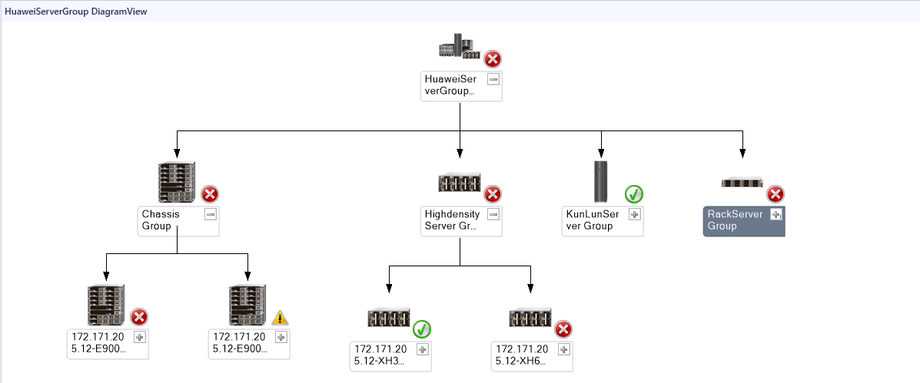

----End

## Viewing a Blade Server Topology

Choose **Start** > > **Operations Console**.



The SCOM main window is displayed, as shown in Figure 7-4.

SCOM main window



Choose **Monitoring** > **Huawei Plugin for eSight** > **Diagram Views** > **Chassis DiagramView**.

The **Chassis DiagramView** window is displayed, as shown in Figure 7-5.

Chassis DiagramView

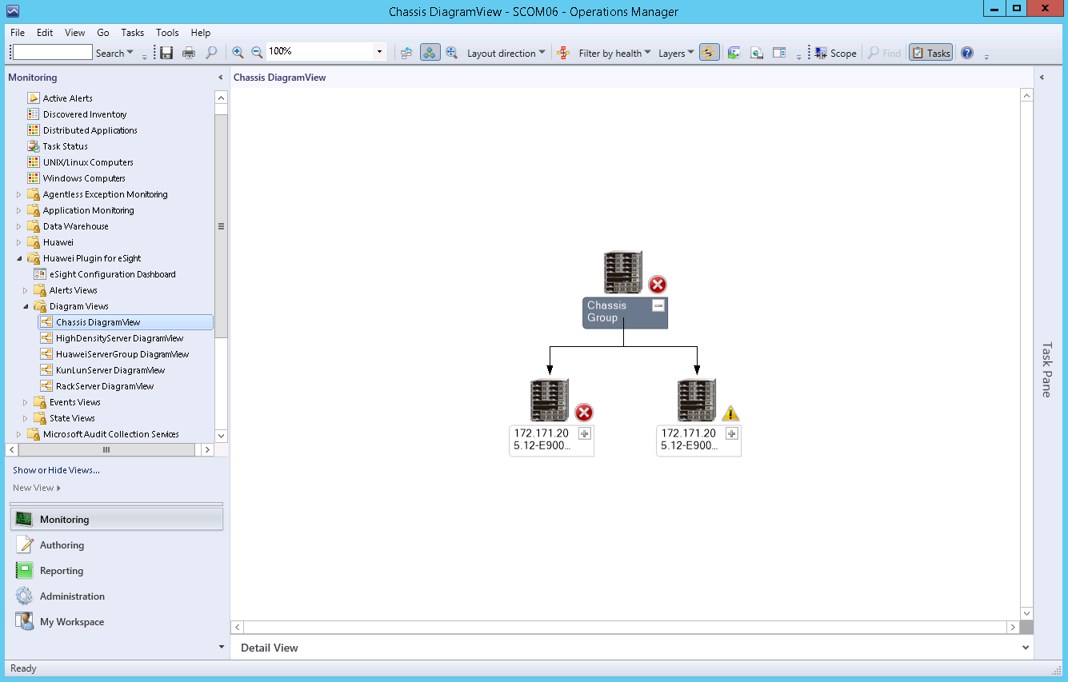

If the topology is not refreshed in time, you can perform the following steps to refresh it:

Open the CLI of the SCOM server.

Access the SCOM installation path (**C:\Program Files\System Center Operations Manager 2012\Console**) on the CLI.

Run the following command to refresh the SCOM window:

**Microsoft.EnterpriseManagement.Monitoring.Console.exe" /clearcache**

In the **Chassis DiagramView** area, click on any server icon to expand the topology of the server type, as shown in Figure 7-6.



Topology

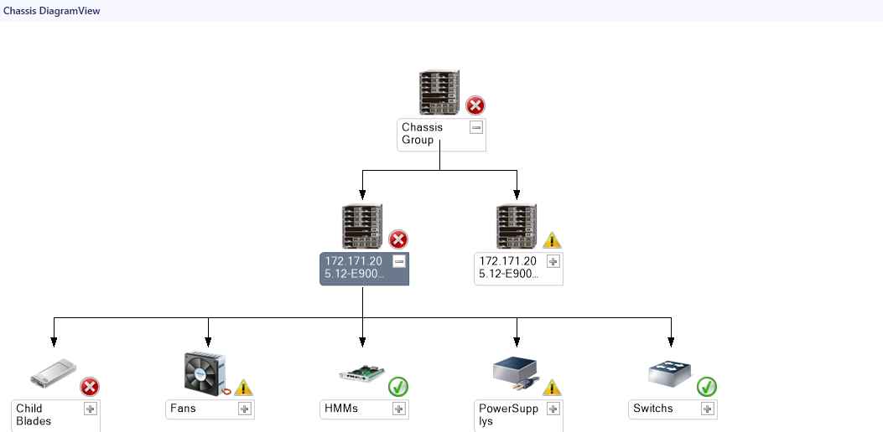

----End

## Viewing a Rack Server Topology

Choose **Start** > > **Operations Console**.



The SCOM main window is displayed, as shown in Figure 7-7.

SCOM main window



Choose **Monitoring** > **Huawei Plugin for eSight** > **Diagram Views** > **RackServer DiagramView**.

The **RackServer DiagramView** window is displayed, as shown in Figure 7-8.

RackServer DiagramView

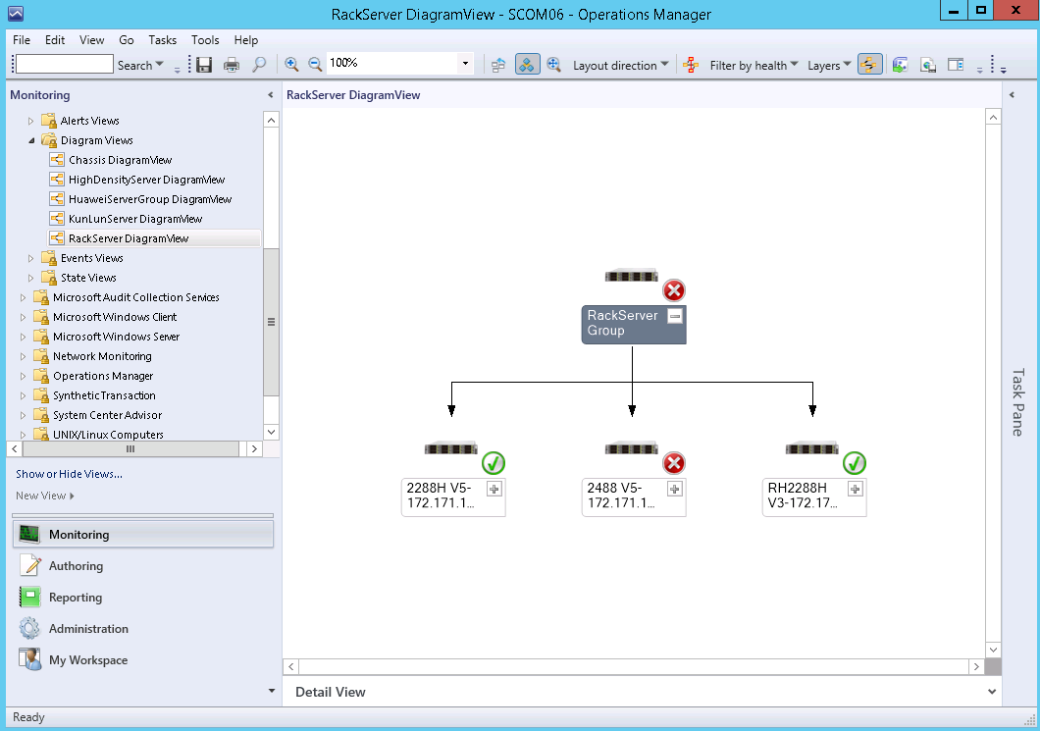

If the topology is not refreshed in time, you can perform the following steps to refresh it:

Open the CLI of the SCOM server.

Access the SCOM installation path (**C:\Program Files\System Center Operations Manager 2012\Console**) on the CLI.

Run the following command to refresh the SCOM window:

**Microsoft.EnterpriseManagement.Monitoring.Console.exe" /clearcache**

In the **RackServer DiagramView** area, click on any server icon to expand the topology of the server type, as shown in Figure 7-9.



Topology

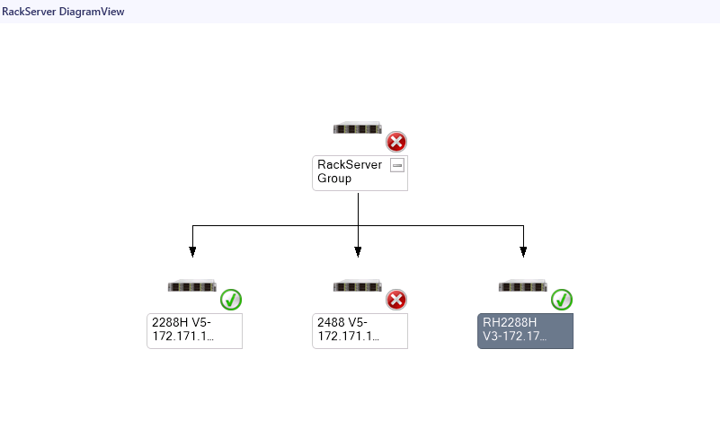

----End

## Viewing a High-Density Server Topology

Choose **Start** > > **Operations Console**.



The SCOM main window is displayed, as shown in Figure 7-10.

SCOM main window



Choose **Monitoring** > **Huawei Plugin for eSight** > **Diagram Views** > **HighDensityServer DiagramView**.

The **HighDensityServer DiagramView** window is displayed, as shown in Figure 7-11.

HighDensityServer DiagramView

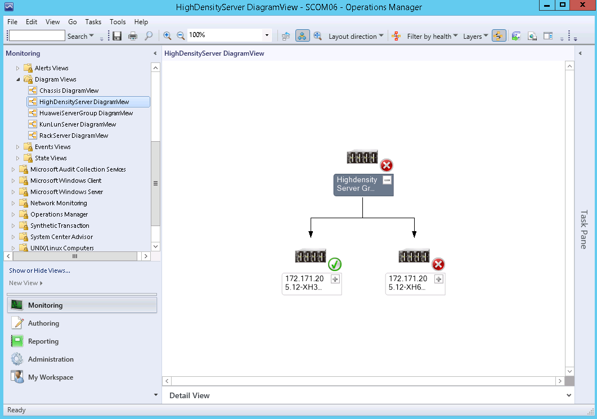

If the topology is not refreshed in time, you can perform the following steps to refresh it:

Open the CLI of the SCOM server.

Access the SCOM installation path (**C:\Program Files\System Center Operations Manager 2012\Console**) on the CLI.

Run the following command to refresh the SCOM window:

**Microsoft.EnterpriseManagement.Monitoring.Console.exe" /clearcache**

In the **HighDensityServer DiagramView** area, click on any server icon to expand the topology of the server type, as shown in Figure 7-12.



Topology

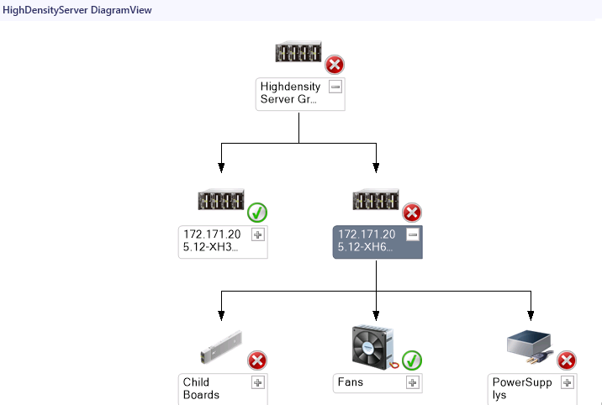

----End

## Viewing a KunLun Server Topology

Choose **Start** > > **Operations Console**.



The SCOM main window is displayed, as shown in Figure 7-13

SCOM main window



Choose **Monitoring** > **Huawei Plugin for eSight** > **Diagram Views** > **KunlunServer DiagramView**.

The **KunlunServer DiagramView** window is displayed, as shown in Figure 7-14.

KunlunServer DiagramView

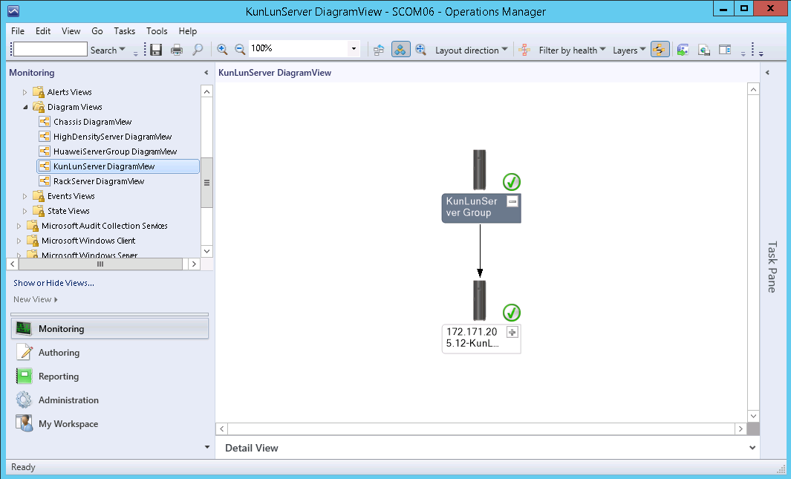

If the topology is not refreshed in time, you can perform the following steps to refresh it:

Open the CLI of the SCOM server.

Access the SCOM installation path (**C:\Program Files\System Center Operations Manager 2012\Console**) on the CLI.

Run the following command to refresh the SCOM window:

**Microsoft.EnterpriseManagement.Monitoring.Console.exe" /clearcache**

In the **KunlunServer DiagramView** area, click on any server icon to expand the topology of the server type, as shown in Figure 7-15.



Topology

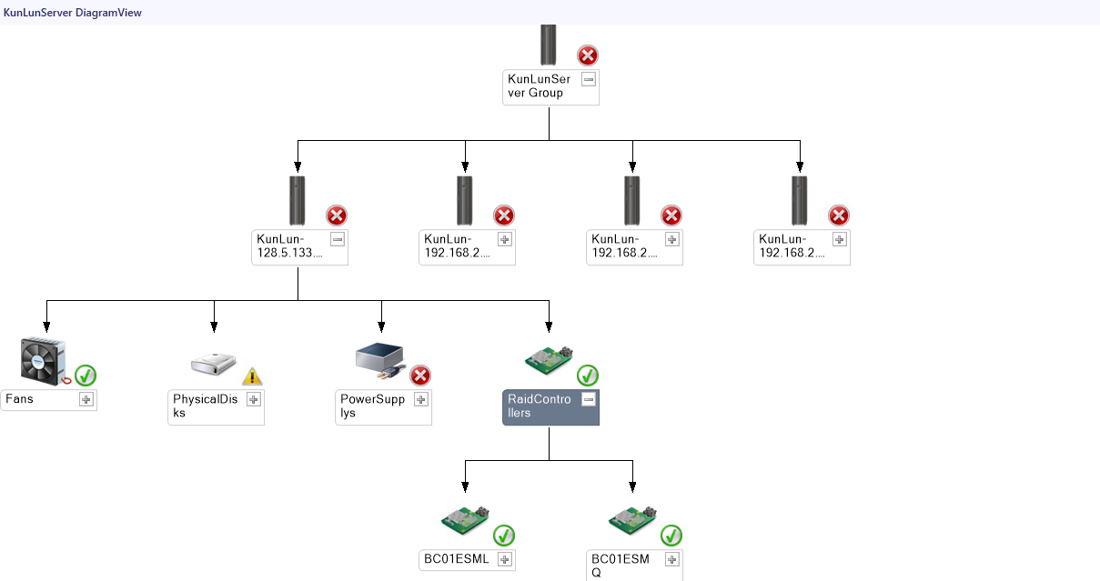

----End

# FAQs

8.1 Connection Test Failed When Adding an eSight

## Connection Test Failed When Adding an eSight

Symptom

After an eSight server is added, a failure message is displayed during the connection test.

Cause

* The user name or password is incorrect.
* The eSight northbound interface user is locked.
* A whitelist has not been set.

Solution

* The user name or password is incorrect.

Enter the user name and password of the eSight northbound interface user. To view the user name and password, perform the following steps:

* 1. Log in to the eSight WebUI.
  2. Choose **System** > **User Management** > **User**. The **User** page is displayed.

The role of the eSight northbound interface user is **Open API user group**, and the user name is displayed under **User Name**.

Viewing information about the eSight northbound interface user



* 1. Click to display the dialog box for resetting the user password.



Reset Password

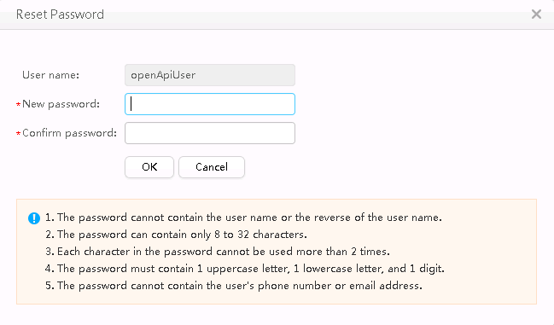

* 1. Enter a password in **New password** and **Confirm password**.
  2. Click **OK**. The password is reset.
* The eSight northbound interface user is locked.

To unlock a user, perform the following steps:

* 1. Log in to the eSight WebUI.
  2. Choose **System** > **User Management** > **User**.

The **User** page is displayed.

* 1. Click to set **Status** of the eSight northbound interface user to **Enabled**.



Unlocking a user



* A whitelist has not been set.

By default, a whitelist of eSight northbound ports is configured. To add an eSight system properly, you must add the IP address of the server where SCOM is located to the whitelist of eSight northbound ports.

* 1. Log in to the eSight WebUI.
  2. Choose **System** > **Northbound Integration** > **Third-party System** > **Create**.

The **Third-party System** page is displayed, as shown in Figure 8-4.

Third-party System



The default value of **System ID** of eSight is **NMSinfo**+*Number of third-party systems*.

* 1. Set the following parameters:
  2. **IP address**: Set this parameter to the IP address of the SCOM server.
  3. **Protocol type**: Select **HTTPS**.
  4. **System ID**: Retain the default value or enter a new value. The value can be an IP address or a string of 1 to 64 characters, including digits (0-9), lowercase letters (a-z), uppercase letters (A-Z), and special characters @_- (), .^$~`!.
  5. Click **OK**.

The IP address of the SCOM server is set as a whitelist, as shown in Figure 8-5.

Set successfully



In the third-party system list area on the right, the value of **System ID** in the row where the SCOM server IP address is located is the eSight third-party system ID.

1. Glossary

E

|  |  |
| --- | --- |
| **eSight** | eSight is a platform related to Huawei server management. |

N

|  |  |
| --- | --- |
| **NetFramework** | Microsoft .NET Framework is a new hosting code programming model used for Windows. It combines powerful functions with new technologies to construct applications with excellent user experience, implement seamless communications across technical boundaries, and support various service processes. |

S

|  |  |
| --- | --- |
| **SCOM** | System Center Operation Manager (SCOM) refers to the Microsoft system center operation manager. SCOM monitors servers, application systems, and clients in the network. It provides a GUI for administrators to monitor faults and alarms of target computers. |